Unloop Full Stack Web Development

Customizing the w3 Framework

## **Overriding Rules**

Frameworks give us nice solutions out of the box…but what if we wanted to *override* a style that was already defined in a framework we are using?

To do this, we need to use our CSS chops by creating our own stylesheet and OVERRIDDING the styles defined in the framework. To do this properly, we need to be careful of three things:

1. The order we import/link the framework and our own stylesheet.
2. The specificity level of our CSS rules.
3. The !important tag.

**Step 1:**

* Create your own stylesheet. This should live in a “css” folder per usual. ☺
* Link to your stylesheet *after* you link to the framework you’re using.

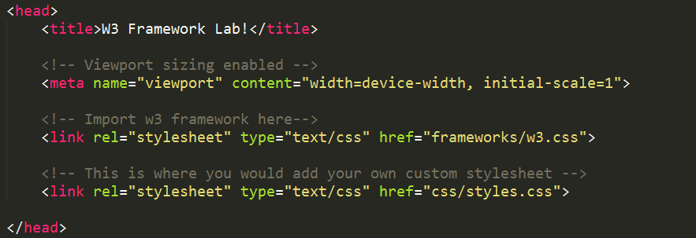

**Step 2:**

* Define a CSS rule on the element you are trying to manipulate.
* Note that, in CSS order AND specificity matter. If the “css selector/rule” that is defined by the framework is more specific or targeted than the one you are defining, the framework will still override your css.

An easy fix for this is to define a new class or id on the elements you want to target.

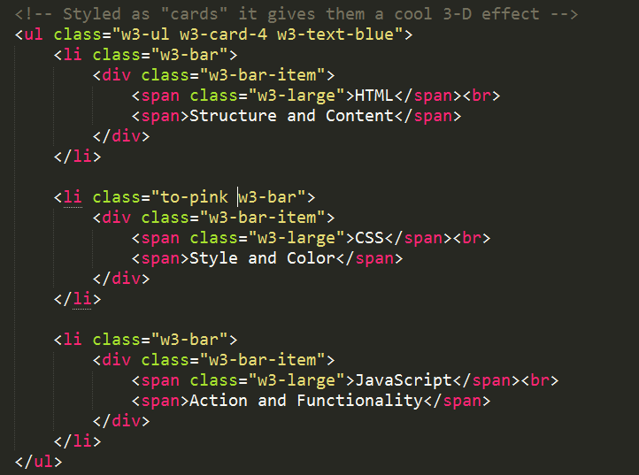

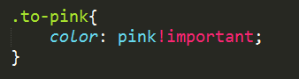

Above: The second list item uses a class named “to-pink.” Even though it is inside a <ul> that uses the class “w3-text-blue,” the styles defined in the “to-pink” class will override it when used in conjunction with the !important tag (see next step).

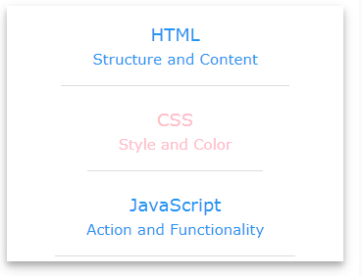

Above: The second list item’s text color renders in pink.

**Step 3:**

When in doubt, include the !important tag next to *all* of your overriding CSS rules.

# ***!important***: An Important Exception

The !important rule can be used after any property value. This will make the *property* marked with !important override rules otherwise considered to have more precedence or weight.

**Checking that our style is being applied.**

1. Inspect the element you are trying to manipulate. (Right click -> Inspect)

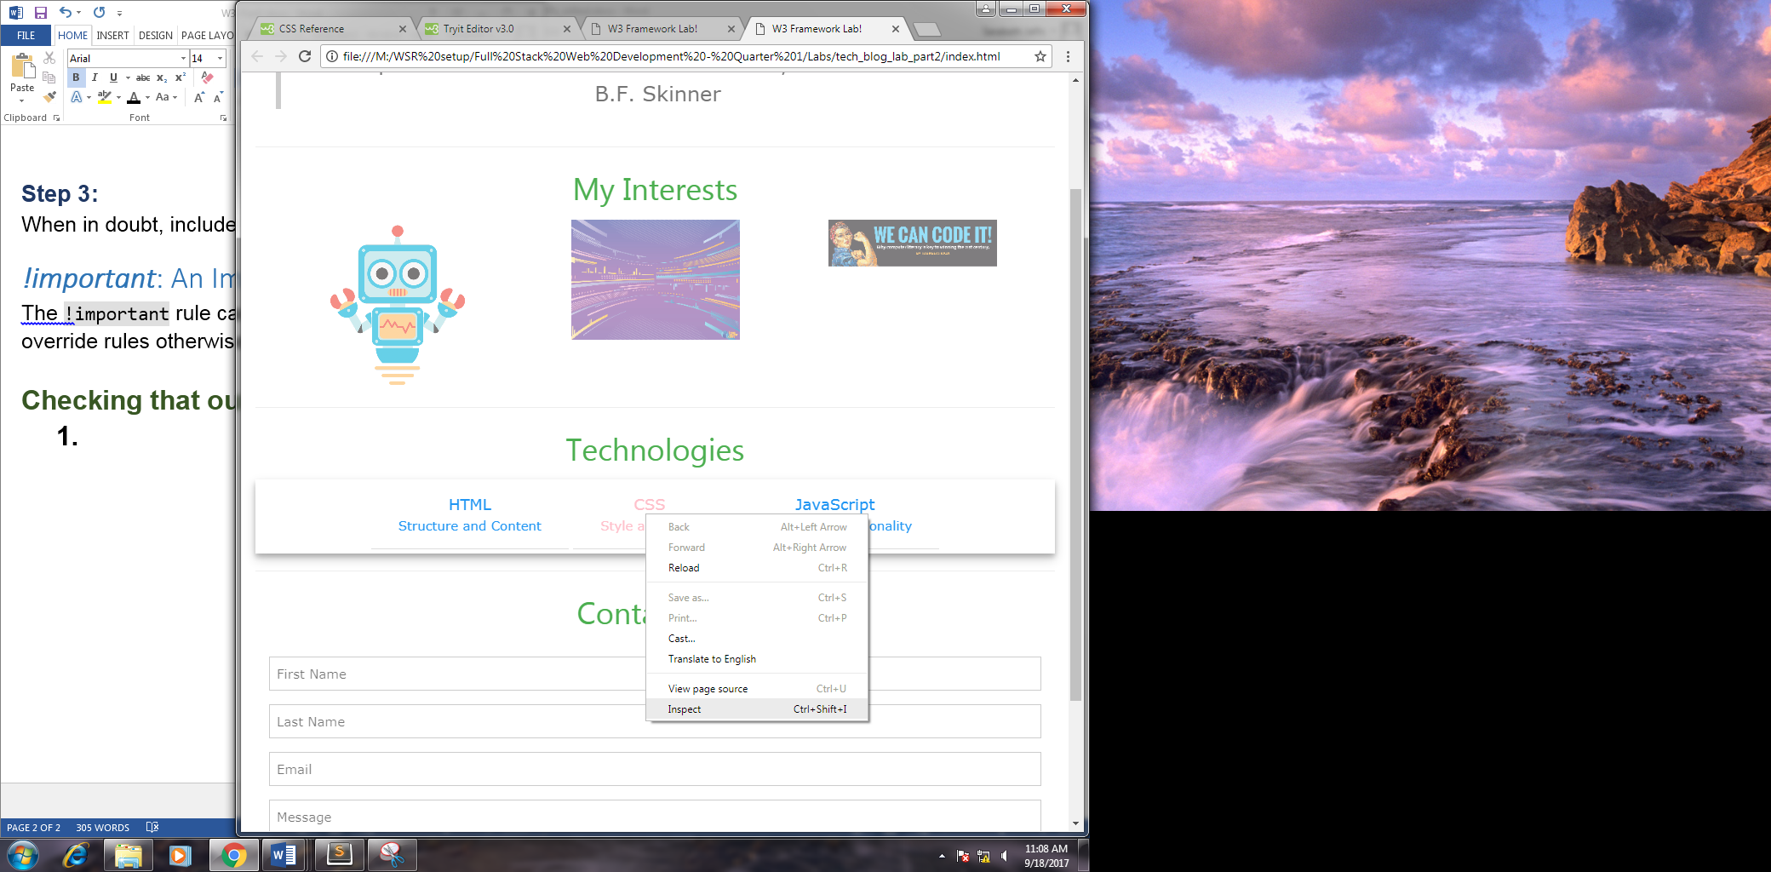

1. This will open up the Google Developer tools.
2. Look under the “Styles” tab. Here you can see all of the CSS rules being applied to that element EVEN THE ONES THAT ARE BEING OVERRIDEN OR ARE ERRORING.
   1. Rules that are being overridden will be crossed out. ~~Example~~
   2. Rules that are erroring/are incorrect will have a small yellow triangle next to them.



1. Our rule should be listed clearly. Reference the underlined file name (i.e. styles.css:10) to find where the rule is coming from as well as the line number it is defined in the file.

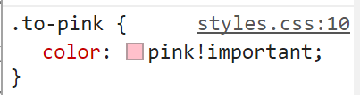

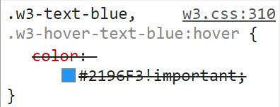

## **New Rules**

When using a framework, you can still add new styles just the same as you would any other website!

Example: Let’s re-size some images with the following vastly different dimensions.

robot.png: 168 x 200 pixels

img3.jpg:1024 x 732 pixels

code_it.png: 960 x 269 pixels



Above: (cropped screenshot) of images with no styles applied. (it’s a mess!)

Steps:

1. Create your custom stylesheet. Link to it in your <head> *after* your framework is linked.
2. Check the existing styles placed on the <img> tag within the w3 framework.
3. Create your height & width rules.

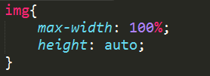

Because these images are inside of a w3-third class, declaring the max-width as 100% will make it so their width dimensions do not span larger than 1/3 the width of the device on large devices and span 100% the width of the device on smaller devices.

1. View your website to see if changes went through.



Above: Images with the custom style applied.

1. If your rule is not being applied, inspect the element in Google Developer tools.
2. Try using a more specific rule or using the !important tag.

**Lab Part 2:**

1. Add at least 3 new rules to your “index.html” website.
2. *Override* at least 3 rules that are set by the w3 framework.
3. Create a text file named “changes.txt” and save it into your project folder. Clearly list the changes you have made.
4. On Moodle, submit your “index.html,” “styles.css,” and “changes.txt” files to the assignment named “W3 Framework Lab.”